

**Task: “Design an advertisement poster for an upcoming Australian Creative Arts festival.”**

**Success Criteria.** *You must include:*

* Research into Australian Art, Music and Theatre/Performance. (Research needs to go into books.
* Annotate each area of your research (who, what, why etc.)
* Plan out a poster which shows a festival including each of your areas of research (try to find artist’s names, a good venue and give a brief list of some of the activities). You can make up your own name for the festival.
* Create your poster using an A4 piece of paper (make sure it is colourful, eye catching)

**Something for the weekend:** (can you achieve gold?)*tick the award you have* completed.

|  |  |  |
| --- | --- | --- |
| **Research a write a biography** for a specific artist, musician or performer from Australia. *Write this in your book.* | **Compare and contrast** how Australian art, music and theatre is the same/different to Wales. *Write this in your book.* | **Attend one of the following and take photos and write a review.**   * Art gallery * Live music * Live performance |

You can put your ‘something for the weekend’ work in your books or email them to Miss Griffiths if you are unable to print it. Email: **griffithsr@pontyhigh.co.uk**

**T**

_________________________________________________________________________________________________

_________________________________________________________________________________________________

**T**

_________________________________________________________________________________________________

_________________________________________________________________________________________________

**Self/Peer-assessment:  
   
  
  
  
Signed: Date:**

**Teacher Comments:**

**Signed: Date:**

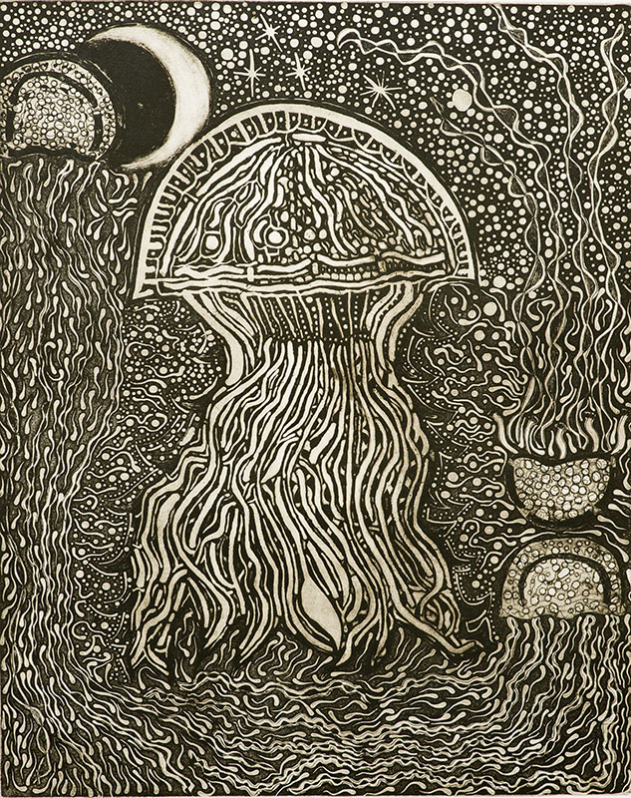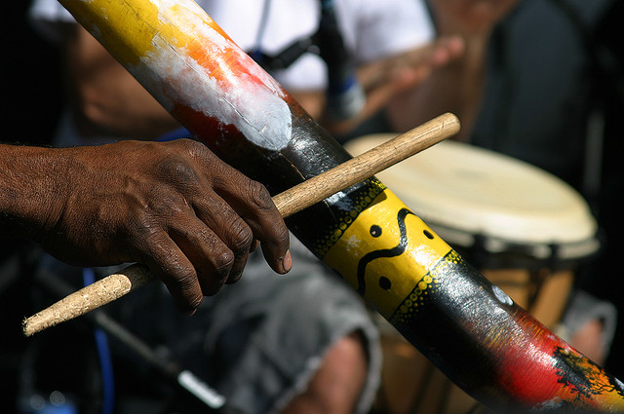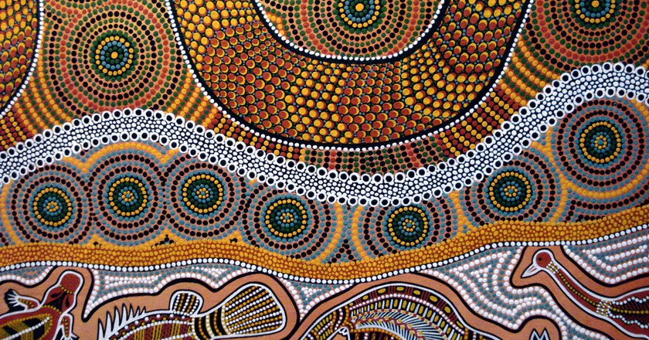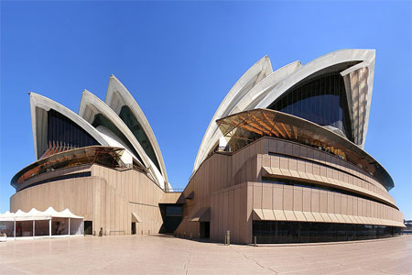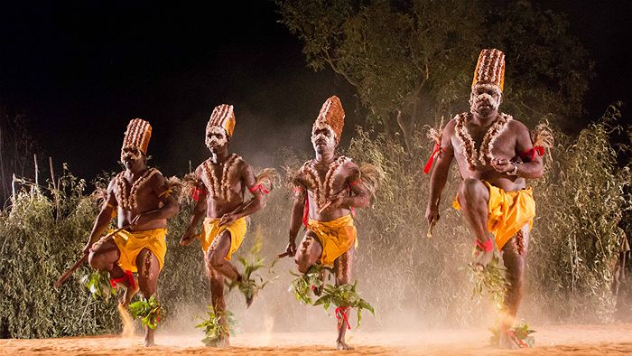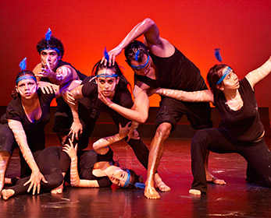

Subject: **Creative Arts**

Discover MORE About the world.